# Change Organizer

In change organizer functionality, organizer can select any attendee in the attendee list, right click on selected attendee, and click on “Assign as Organizer” option as highlighted on below screen shot (Figure 1).

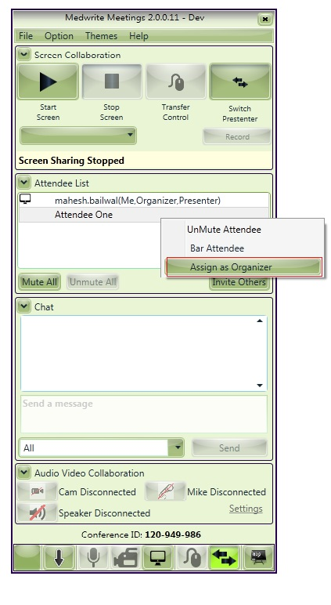

*Figure 1*

The selected attendee has all the organizer rights on his screen (see in Figure 2) and previous organizer becomes the normal attendee of the meeting. As the pervious organizer is now normal attendee in case if he leaves the meeting, then meeting will not be end. New organizer can also delegate the organizer any of the attendee in the meeting.

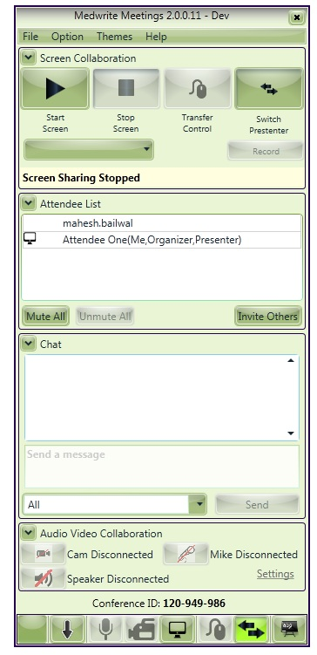

*Figure 2*

**Export to Excel and Pdf**

The new functionality for exporting data in pdf and excel format been added to the reports in admin website. For exporting reports in pdf and excel format user need to click on the pdf or excel icon at top right side of the report as displayed in below screen shot . The data for all the pages in the report will get exported in the pdf/ excel format as per user action.

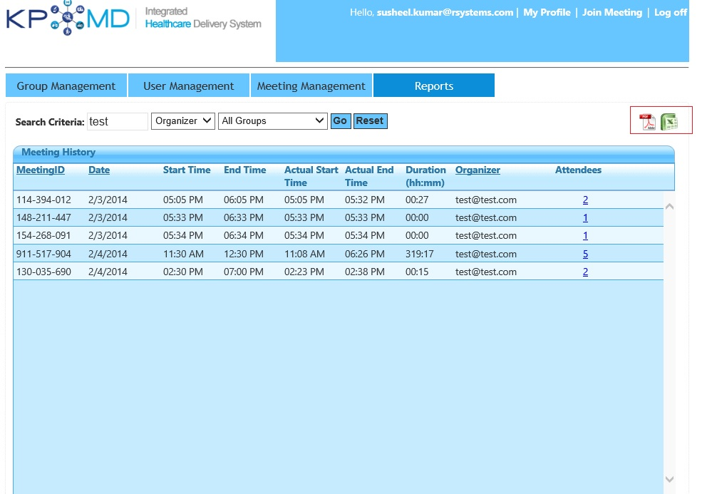

*Figure 3*